Hong Kong University of Science and Technology

Final Year Project Report
Peer –To – Peer IPTV – TD1a-09


Project Supervisor : Prof. Danny Tsang
Signature : ___________________

conducted by : Cheng Wen Chi, Vinci (07481136)_____________
Chiu Kwok Shing (07323530)________________
Choi Kwok Yam, Alex (07483512)_____________

School of Engineering – BEng of Computer Engineering
Date: 07-04-2010

EXECUTIVE SUMMARY

Nowadays, Internet has become part of our life. Domestic users enjoy various kinds of entertainment online within the high speed network. The introduction of P2P technology also boosts up the performance of Internet application. IPTV is one of the hottest online applications which make use of P2P technology. This IPTV project aims to introduce a P2P IPTV with live HD streaming under a scalable system. The greatest challenge of providing HDIPTV is the network speed and stability of clients’ computer internet connection. To solve these problems, our P2P IPTV system applied hybrid connection model which include the push mode and pull mode on cool streaming model. The hybrid mode model has perfectly delivery the video stream to each IPTV client in our final product. It achieved a HDTV (480p) live TV with multiple broadcast channels under HK internet environment.
Table of Contents
1 Chapter Overview 4
1.1 Introduction 4
1.2 Aim and Objectives 5
1.3 System Block Diagrams 6
1.4 Design Specification 7
2 Background Information 10
3 Methodology 12
3.1 Design Phase 12
3.2 Technical Challenges 13
3.3 Implementation Phase 14
3.4 Testing Phase 14
3.5 Evaluation Phase T14
3.6 Schedule of Responsibilities 15
4 Video library Implementation (Chiu Kwok Shing) 16
5 Data Encryption and Decryption (Choi Kwok Yam) 20
6 Sub-streaming and push mode (Choi Kwok Yam) 22
6.1 Multiple Sub-streams 22
6.2 Push mode 22
7 XML Database (Chiu Kwok Shing) 24
8 Tracker server (Cheng Wen Chi) 25
9 Channels Selection and Connection (Cheng Wen Chi) 26
9.1 Connection establishment and registration 26
9.2 Deregistration and Recursive Deregistration 28
9.3 Peer selection in peer list 30
10 Reconnection and Loop Detection (Cheng Wen Chi) 31
11 Pull-Mode Implementation (Choi Kwok Yam) 33
12 Statistic Application (Chiu Kwok Shing) 36
13 Discussion and Conclusion 39
Reference 40
Appendices 42

- Chapter Overview
  - Introduction

With the development of networking technology, broadband has become more and more popular in the world. According to data and statistics from Office of the Telecommunications Authority (OFTA) [10], the household broadband penetration rate of Hong Kong is reaching almost 77% in May 2008, which is higher than the average standard of developed countries [11]. Having such advanced environment, many user have a great thirst on high quality networking multimedia service.
In accordance with the statistic of OFTA in 2009[12], there are 1.08 million IPTV subscribers in Hong Kong at December 2008 which is the highest in the world in terms of household penetration.

Home users demand for higher quality of online video service. YouTube, the most famous video sharing website, has just announced that users now have the option of watching some video in 720p HD, much better than 320x240 video in the past.

High-Definition television broadcast technology is commonly used all around the world. Most of them are not broadcast through Internet, while some of them are broadcast through satellite. As channels collection is much boarder than traditional TV broadcast, it attracted more users to watch TV program through internet broadcast. The free television broadcast providers (TVB & ATV) in Hong Kong started the HDTV broadcasting since 31st December 2007.^{[13]} Customers can enjoy TV program with resolution not less than 480P. In Europe, the first European HDTV channel starts to broadcast since 2003. Up to end of 2009, there were 114 HD channels broadcasting from Astra satellites ^{[14]}.

In traditional client-server mode, IPTV required a server with high processing power and large bandwidth in order to provide a high quality online video service. Thus, a large investment is required to build high efficient server and network thus makes investor hesitate to start such project.

Peer-to-Peer (P2P) Technology presents a great advantage over the traditional client-server model. In P2P model, clients will work as a part of the service provider when they join into the mesh network, which lower the workload of server. Applying P2P technology, the required network resources from the server will be reduced. Thus, we can provide more users with the same amount of resources. Considering the well developed broadband network in Hong Kong, we can use P2P technology to provide user high quality IPTV.

  - Aim and Objectives

This project examines streaming Internet Protocol Television (IPTV) over peer-to-peer networks with high resolution video. The aim of this project is to investigate the different approaches of P2P video streaming in order to create a low delay, high quality IPTV application, thus different P2P algorithms may be applied, such as pull-based, pure push, hybrid, etc.

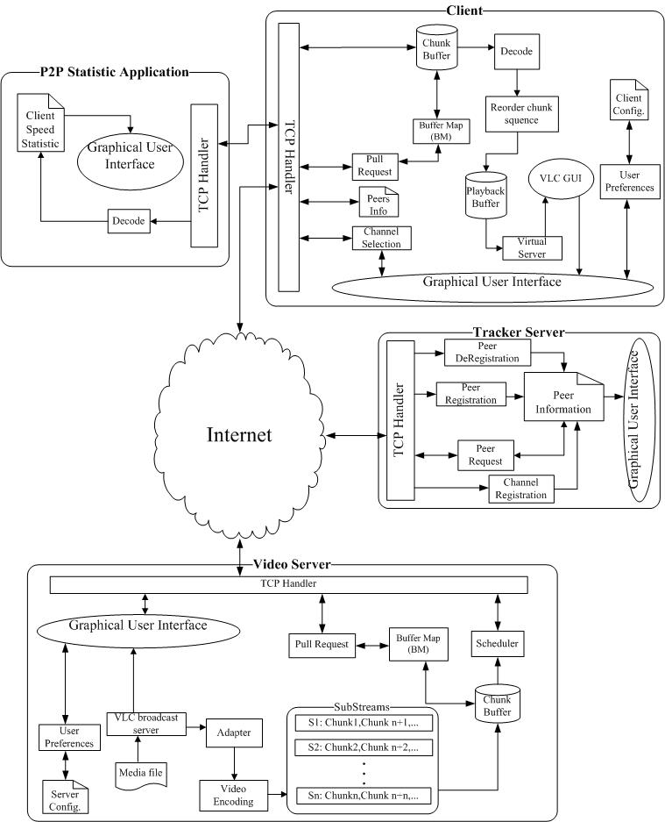
  - System Block Diagrams

Fig.1 – Whole System Block Diagram
  - Design Specification

Component description
Components | Functions
Tracker | - Peer registration  - Peer deregistration  - Channels maintenance  - Peer lists maintenance
Server | - Sub-streams maintenance  - Video TRANSCODING  - Preview broadcasting video  - Upload stream handle  - System setting
Client | - Sub-stream reordering  - Missing chunk recovery  - Channels selection  - Upload stream handle  - Playback the video
Statistic Application | - Display the upload and download speed

Design Specification
Protocol | TCP, HTTP
3rd parties program library | VLC player API, ZepGraph lib, XCoolForm lib (GUI), MediaInfo.dll
Supported video type | WMV, AVI
Transmitted data type | TS
Supported video resolution | 480P or lower (1500 Mbits/s)

Working Environment Requirement

Server:
Operation System | Windows XP or above
Network Speed | 10 Mbits/s or above
Processor | Pentium 4 or above
Memory | 1GB or above

Client
Operation System | Windows XP or above
Network Speed | 3 Mbits/s or above
Processor | Pentium 4 or above
Memory | 512 MB or above

  - Report Outline

Chapter 2: Background Information
This chapter is a review of the background materials. This includes the brief introduction on P2P technology and the aim of our project.

Chapter 3: Methodology
3.1 Design Phase
This chapter explains the methodology we adopted in this project. Restate the problem looked at and ways that we have taken to solve these problems.
3.2 Technical Challenge
State the challenge in our project.
3.3 Implementation
State number of stages there were in the project.
3.4 Testing
State the tests performed in our project
3.5 Evaluation
State and analysis the result obtained.
3.6 Schedule of Responsibility
Gantt chart and a task list with a clear summary of the responsibilities of each member of the Team.

- Video Library Implementation
4.1 DLL Library Creation for VLC library Access in C#
Explain the function of VLC DLL library within the system.
4.2 Video Broadcast function
Explain how to broadcast video using VLC DLL library.
4.3 Virtual Server broadcast and Video playback buffer
Introduce the virtual server function and video playback buffer that assist the video playback function within Client-side application.
4.4 Video bitrates checking
Introduce the MediaInfo.dll that applied in the project.

- Data Encryption and Decryption

- Sub-streaming and push mode

- XML Database
State the reason we choose XML file type to develop database and how it works.

- Tracker server

- Channels Selection and Reconnection

- Reconnection and Loop Detection

- Pull-Mode Implementation

- Statistic Application
Statistic application is a tool we developed to measure client-side application network speed, thus to evaluate the client-side application’s performace.
Introduce the reason to develop Statistic application and how it works.

- Discussion and Conclusion
Discuss the result we obtained, discuss the relation of them and verify it.
Then briefly restate the problem we looked at, and the methodology to solve it.

- Background Information

P2P model is widely used for file or data sharing in modern internet. In P2P model, clients become participators in the data upload. The transmission speed is no longer based on the server throughput (server-client model), but determined by the throughput of both the peers and the server. Theologically, the performance of P2P network will be improved with the increased number of peers. The bandwidth of client computers have increased rapidly in the past few years, thus optimizing the working environment for P2P model. The workload and dependence of server throughput is also reduced by P2P model. As a result, much stable and high data throughput can be achieved in the same topology.

Entertainment has become the main function of the home PC. Online movies, TV, music are common home entertainment. Users enjoy different kinds of online entertainment through their broadband connection in different countries. Most of the online multimedia applications need to deliver a large amount of time sensitive data. The multimedia streaming leads to a significant problem for server to deliver a stable service to large number of clients. P2P model has become one of the most feasible solutions for multimedia data delivery. IPTV is a signification example of multimedia streaming those benefits from the P2P model. In the past, it is almost impossible to deliver real time TV broadcast through the internet. The throughput of the server did not meet the needs of high bit rate of data stream in the client-server model. However, after P2P model is applied, the throughput of the downloaded stream in each client has significantly increased, and the data streaming is then allowed to support the high bit rate of the video. As a result, most of the popular P2P IPTV systems use P2P model to provide their service.

High and stable throughput of the data streaming is critical factor in P2P IPTV performance. The construction of P2P streaming network is the most important for P2P IPTV, as it will drive the performance of data streaming.

There are two major design considerations in the construction of P2P streaming system:
- forming an overlay topology between peers
- delivering video content efficiently
According to the researches papers [3] [4], there are two common basic approaches to construct P2P network, mesh pull and tree push. For tree push, peers are connected in tree-shaped overlay and video data is pushed out from root (server) to peers by passing through the tree hierarchy. For mesh pull, peers form a mesh-shaped overlay and they pull video from each other by sending request to a peer.

Recently, there are numbers commercial P2P IPTV has been successfully deployed. According to articles [1][2], those IPTV users are increased exponentially in these few years. PPStream, PPlive, SopCast are examples of common P2P IPTV. Most of them apply the mesh pull algorithm to deliver the service, and TCP to ensure the reliability of delivery. The mesh-pull system is popular for P2P IPTV as it is relatively a simpler design principle than tree push. However, they demonstrated some common problems, such as large initial delay, high reconnection latency and high disconnection rate.

In this project, our aim is to implement a high quality and stable IPTV system with a optimize P2P model. The academic papers [4] indicate tree-push provides a better performance in practice. Tree push causes a lesser overhead in data streaming over mesh pull and it will be further discussed in the methodology section of this report.

- Methodology

- Design Phase
Description of the Proposed Solution to Establish P2P-IPTV System

Mesh-pull architecture

Bearing strong similarities to BitTorrent, mesh-pull streaming deviates significantly from BitTorrent in various aspects [3]. The mesh-pull systems apply a simple design principle and suitable for high dynamic, high-churn P2P environment [5].In Mesh-pull streaming, the hosts exchange the Buffer Map [7] and retrieve the missing chunks. Every chunk has a playback deadline, so video chunk scheduling algorithm is indispensable. Gossip based peer search algorithm is implementing in mesh-pull system to support large-scale group communication. However, gossip algorithm incur various implications, i.e. delay may occur in searching peer; tracker server may only handle part of peers in the system and lose the global view of the network[3].Another, mesh-pull systems always suffer from high traffic overhead, long start-up delays, video channel switching delays and peer playback time lags[3].

Tree-push architecture

Tree-push systems may achieve high throughput, low overhead, fast start-up time and small delay, if the tree structure does not break down due to peer churn and peers at the higher level of the tree have sufficient upload capacities to support streaming for their children peers [6]The tree construction mechanism can optimize the tree so as to reduce stress on the underlying network. In tree-push streaming, peers share the video chunk to their children peers immediately. Buffer Map [7] and retrieved missing chunks will not apply in this streaming system. This increase recovery time of data stream under the reconnection states

Hybrid-mode architecture

Undoubtedly, either mess-pull or tree-push architecture have their pros and cons. As a result, a system that combines mess-pull and tree-push architecture will be a perfect solution for P2P-IPTV system. Hybrid-mode is an architecture that draws the advantages of both mesh-pull and tree-push algorithm.

In this project, Hybrid-mode architecture is applied in system design. Tree-push will be used to develop the overlay topology, and mesh-pull is used to enhance the system stability.

Tree-push provides low delay and low overhead data streaming when compare to mesh-pull which is advanced for IPTV. However, tree-push has a low performance on rebuilding data sub stream when there is reconnection of connection. Therefore, we enhance the system performance with several algorithms to minimize the instability. Multiple trees and sub streaming will be applied into the tree-push. Sub-streaming divide video stream into different sub stream with in equal weight, and each data is assigned a sequence number to represent its play black order in the stream [8]. Each sub-stream use separate tree to broadcast. Peers join as many trees as there are sub-streams that they want to receive.

To further enhance the stability of the system, pull-mode will be applied into the client-side application. While pull-mode is enabled in the system, system will keep track on the index number of latest chunk that received from the parent peers and predict the index number of the next chunk will be received. System will pull the missed packets from other peer if the received chunk index number is not identical to the predict index number. Packets that missed in tree-push core algorithm may be recovered through mesh-pull algorithm.

Technical Challenges
We encounter numerous of technical challenges during the development of the project:
- Unsteady and Video lag problem in Client-side Video playback

Video playback performance will be varied between different clients on same video source which due to variation of their bandwidth. Furthermore, unstable network environment will result packets lost during transmission, video playback quality will be worse and look unsteady.

Relieving the video lag problem to enhance the video playback quality, buffer is added in the receiving network thread. (Please view more detail explanation in Chapter 4.3 – Virtual Server broadcast and Video playback buffer)

Further enhance the video playback quality, Pull-mode is applied is client-side application. (For more details, please visit Chapter 11, Pull-Mode Implementation)
- Disordered sub stream delivery
Due to the unstable network environment, the delivery of the sub stream data chunk will be disordered. This leads to a problem of reconstructing the original video stream for playback on peers.
- Tree Hierarchy Problem
Within our system, a hierarchy is set up between parent and child node. Relation between parent peer and child peer will be vary while any one of the peers joining or leaving the topology in random time. Ordered hierarchy will be disturbed and cause error to the system due to improper hierarchy maintenance.
- Topology loop problem

- Over centralized peer directory
- Implementation Phase
As this project is complicated, the system is divided into several system and implement in different stages:

States | Details
State 1 | VLC library implementation
State 2 | Data Encryption and Decryption implementation
State 3 | Cool Streaming Implementation and Testing
State 4 | Sub-streaming and push mode
State 5 | XML Database
State 6 | Tracker server
State 7 | Channels Connection and Reconnection Handling
State 8 | Reconnection and Loop Detection
State 9 | Pull-Mode Implementation
State 10 | Statistic Application

- Testing Phase
(Incomplete)

- Evaluation Phase
(Incomplete)
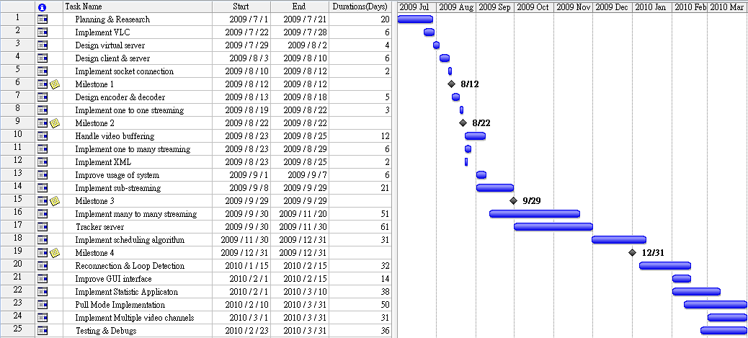
- Schedule of Responsibilities

Milestones 1: Client connects to server and requests the data packet
Milestones 2: Client can playback the streaming video through one to one broadcasting.
Milestones 3: One-to-many broadcasting and using sub-streaming method.
Milestones 4: Delivery a complete P2P IPTV system.

Responsibility of each Task:
Name | Task Number
Cheng Wen Chi | 1,4,8,10,11,13,17,18,20,23,24,25
Chiu Kwok Shing | 1,2,12,16,18,20,21,22,23,25
Choi Kwok Yam | 1,3,4,5,7,8,11,13,14,18,20,23,25

- Video library Implementation (Chiu Kwok Shing)

- DLL Library Creation for VLC library Access in C#

VLC player is an open source cross-platform media player that supports variety of media formats ^{[18]}, such as DivX, MPEG 1, 2, and 4, MP3 and MP4, AVI, WAV, SDVD, SVCD, DVD, VCD, and regular CD formats. It composed by more than 380 modules, developer can apply its function through its open sourced VLC library.

The DLL library of VLC is a video player library that developed by C++. Since our system is developed by C#, it’s difficult to utilize the function in the VLC DLL file directly. As a result, our system has developed a DLL library to act as an interface between VLC library and our P2PIPTV system.

Because of the modular-base design of VLC player, developer can make use its function separately instead of include its whole component like windows media player plug-in. It gave us a great flexibility to develop our own GUI, thus we can just apply the function that we needed, such as video and audio output, video streaming function and player controls within VLC DLL library, etc.

The role of VLC player library in our design is to act as the end application within the system. It provides all fundamental media player function, such as “Play”, “Start”, “Stop”, video encoding / decoding, etc.

All work for media file encoding / decoding will be executed by the VLC player.

Thus, we do not have to study large amount of documents on media format which will take even much more time. Then more time can be used to develop the core of the P2PIPTV algorithm design.

- Video broadcast function

Due to the modular-base design of VLC DLL library, we can apply the video streaming function of VLC player through our own VLC access DLL library. A broadcast function is developed in the system to broadcast video through VLC DLL library.

It will exist in the bottom of both layer of the system within the video server and the client-side application. Please view the figure 4.2.1 for reference.
A

B
Fig.4.2.1 System Block Diagram Indication

While users start the video server in the system, VLC DLL library will convert the video file within the video server and broadcast it to adaptor with local address (http://127.0.0.1: port number). Then the adapter will redirect the data to another function within the system to perform video segmentation, encoding and some other operation (Layer A mark in the below diagram), the prepared data will eventually send to internet through TCP handler.

Similarly, for the application in the client side, video data received by TCP Handler will pass to functions we developed (Layer B mark in the above diagram) to decode and reorder. Then the prepared media content will be stored in a buffer and send to the virtual server within client-side application and eventually received by the VLC player plug-in and converted to video and show in the GUI.
So the whole system can be simplified as follow:
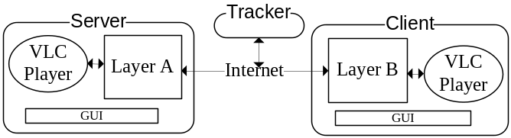
Fig. 4.2.2 Simplified System Block Diagram

- Virtual Server broadcast and Video playback buffer

- Virtual Server broadcast
Within the Video Server, Video playback function is handled directly by VLC core player at the same time it broadcast the video. However, VLC cannot efficiently handle the video data processed by our system directly within the client-side application; a virtual server has developed to assist the video playback function in the client-side application.

The virtual server is developed to handle the VLC broadcast data. It will read data from local buffer and then sends the data back to VLC core player through local loopback address. It means that the VLC core player will connect to the local address (http://127.0.0.1:port number) to playback the video within the virtual server. As a result, the virtual server becomes the link between VLC core player and our program that handled P2P information. The operation flow is shown in Figure 4.3.1.
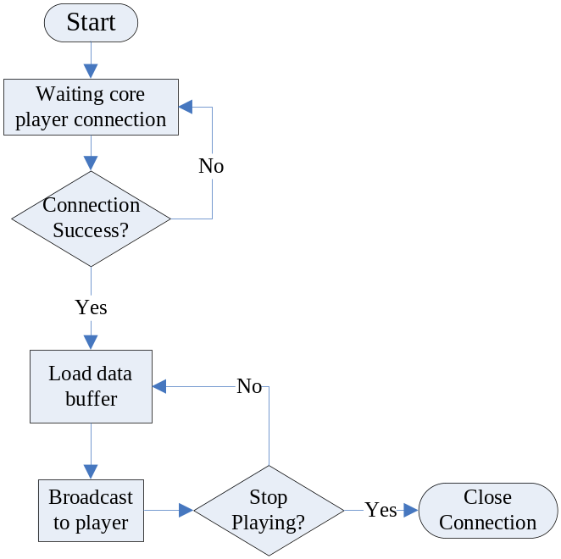
Fig 4.3.1 Flow chart of virtual server operation
- Video playback buffer
As the problem stated before, video playback performance will be worse than it expected due to the unstable bandwidth, video lag will be happen regularly.

To reduce the effect of this problem, buffer is added in the receiving network thread. The playback buffer will accumulate certain amount of data chunks before it send to Virtual server and then VLC core player start playback. While the accumulated data chunk within playback buffer is below certain amount, it will not send data to virtual server until the received data accumulated to an acceptable value, the VLC core player call the “PAUSE” function to stop video playback temporary since it cannot receive video data from virtual server.

Operation flow of the player back buffer is shown as follow:
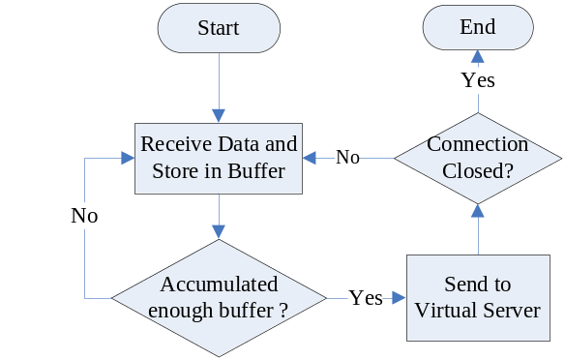

- Video bitrates checking

Since VLC DLL does not provide an accessible function to obtain to obtain the technical information and tags of multimedia file, another third party library call “MediaInfo.dll ^{[20]}” is applied within the project.

Through the video library in our system, program will apply the function within “MediaInfo.dll” and obtain the video information such as “video bitrates”, “Audio bitrates”, “video codec’, ‘playtime”, “audio codec”, etc.

This multimedia information will then broadcast to the all P2PTV peers. Using this technical information, settings can be optimized in the client side, such as increase the video buffer and playback resolution while playing high bitrates video.
- Data Encryption and Decryption (Choi Kwok Yam)

Container is file that contains video and audio. The video and audio is encoded using codec’s [14] and then stored in a container. The VLC streaming server provides four containers for broadcast the video through HTTP [15] protocols. Figure 5.1 shows the types of container (PS, TS, Ogg and ASF) and their properties.

 |  | PS | TS | Ogg | ASF
Video formats | MPEG-1 video
Video formats | MPEG-2 video
Video formats | MPEG-4 video
Video formats | DivX 1/2/3 video
Video formats | WMV ½
Video formats | H/I 263
Video formats | H.264/MPEG-4 AVC
Video formats | MJPEG
Video formats | Therora
Audio formats | MPEG Layer 1/2/3 audio
Audio formats | AC3
Audio formats | MPEG-4 audio
Audio formats | Speex
Audio formats | Vorbis
Audio formats | FLAC
Audio formats | PCM
Audio formats | A-Law
Fig. 5.1 the properties of containers

Transport Stream(TS) [16] is used in the VLC streaming server because it supports a lot of video formats. Figure 5.2 shows the packet structure of transport stream. The packet is fixed size of 188 bytes. The payload portion of the packet is 184 bytes and the header is 4 bytes.

4 Bytes 184 Bytes

Header
Video Payload

Fig.4.2 Structure of Transport Stream
Sub-Streaming method is implemented in our system. In the P2P streaming server, the TS packet will be encoded to the streaming chunk before being sent to the sub stream. The Client needs to decode the streaming chunks and reorder the TS packets for the video playback. In figure 5.3, each streaming chunk divides into two parts: Header (Sequence Number + Total TS packet length) and Payload (TS packets). A sequence number is used to reorder the streaming chunk. The total TS packet length is the size of the TS packet in the data part.
The size of payload depends on the video bitrates and the network bandwidth. For example, broadcasting a video with 400Kbps and the maximum size of the payload will be defined to 3760 bytes. The number of TS packets (payload size / each TS packet size) = (3760 / 188) = 20. The video playback time of each payload (1/ (video bitrates / payload size)) = (1/ (400/30080)) = 0.07 sec. Therefore, one sec. movie clip require 13 payloads or above to playback.

<Header> <Payload>
182 Bytes (Number of TS packets* 188) Bytes
…
TSPL
SN
TS TS

SN: Sequence Number
TSPL: Total TS packet length
TS: Transport Stream packet
Fig. 5.3 Structure of the streaming chunk

TCP protocol is used to transmit the streaming chunks over the internet. Each streaming chunk will be encoded to TCP packet. Figure 5.4 shows the overhead of each streaming chunk is 40 Bytes.
40 Bytes
TCP Header
Data Payload
…

TS
Header
<Streaming chunk>
Header
Video Payload
<TS Packet>

Fig. 5.4 Structure of the TCP packet
- Sub-streaming and push mode (Choi Kwok Yam)
…
Single stream of chunk with Sequence number {1, 2, 3…10}

10
9
6
5
4
3
2
1

Combine & Decompose

Three sub-streams {S_{1,} S_{2,} and S₃}
…

S₁
1
4
7
10

…
S₂
2
5
8

…

S₃
3
6
9

Fig. 6.1 Example of stream decomposition

- Multiple Sub-streams
The video stream is divided into different chunks and each chunk is assigned a sequence number to represent its playback sequence in the stream. One of the key factors contributing to the success in P2P file sharing applications is the adoption of the gossip concept, in which a node can request different small chunks of file content from different nodes. This achieves significantly improvement on efficiency compared to other traditional systems [8].

After the parent-child relationship is established between two peer nodes with the TCP connection, the child node will be received sub-stream(s) from the parent node. The video stream is decomposed into P sub-streams by grouping the chunks according to the following scheme: the q-th sub-stream contains chunk with sequence numbers (nP + q), where n is a positive integer from zero to infinity, and q is a positive integer from 1 to P. This implies that a child node can at most receive sub-streams from P parent nodes. Fig. 6.2 shows the video stream divided into P sub-streams.

- Push mode
The chunks are passed down from one parent node to another child node. The parent node and child node does not exchange the required sequence number of chunks need in the normal push mode. The parent node will send the latest chunk to the child node continuously after the TCP connection is established. The data stream will only pause or stop when there is TCP congestion or TCP timeout on the data stream connection.
(n-1)P +1
nP + 1
…
S₁
1
4
S₂
2
5
(n-1)P +2
nP + 2
…

.
.
.
.
.
.

…
S_{P}
P
2P
(n-1)P + P
nP + P

n

Fig. 6.2 P number of sub-streams

- XML Database (Chiu Kwok Shing)

Many settings and users’ preference will be modified frequently to adapt different system environment, such as start buffer size, tracker IP address and maximum peers’ number, etc. It needs a GUI page for user to modify setting that need to be set or changed within the system depends on various conditions. Our system provides a setup page for user to set and modify the specific settings. This function will exist both in Video Server and Client-side application.

To enhance the efficiency of data storage and access, a database system is developed by XML (Extensible Markup Language) ^{[19]}. It’s a file type that included a set of rules for encoding document. It provides an open standard which supported in different programming language and platform. In Visual C#, there is a build in library which allows software developers to access XML data.

XML simplify the access of peer data. Client computer will not need to install external database management system (DBMS) such as Oracle or MySQL to support the P2P system. This helps to reduce the operation cost of the client system.

User will modify the setting easily from the GUI, and then the program will convert these data into a XML file format. To implement these data, application can use the library built-in function to get the data that stored in the XML file.

XML database is further implemented in various part of the project:
- Server and Client Configuration
- Peer Information within the system
- Statistic record

Since user able to access and edit the database content easily through the XML DLL library, peer connection information and statistic application record are stored as XML record either. Both server and client side application will access the database easily through the XML DLL library, and do not need to install any other software.

- Tracker server (Cheng Wen Chi)

The maintenance of many-to-many connection is one of the most important parts in a P2P system. When new peer join into a P2P network, it needs information of other peers in the topology. This information includes the peers’ IP address, service port, bandwidth, etc. The new peer will select peers based on this information for the new connection. Thus, it will build its connectivity with different peers and download the data from them under the P2P model.
Tracker is the sub system which dominates the connection establishment processes. Tracker server is a centralized database which maintains complete record of peer information. It responds to maintain the topology of the P2P IPTV network and provide the accurate peers’ information to every peer in the topology.
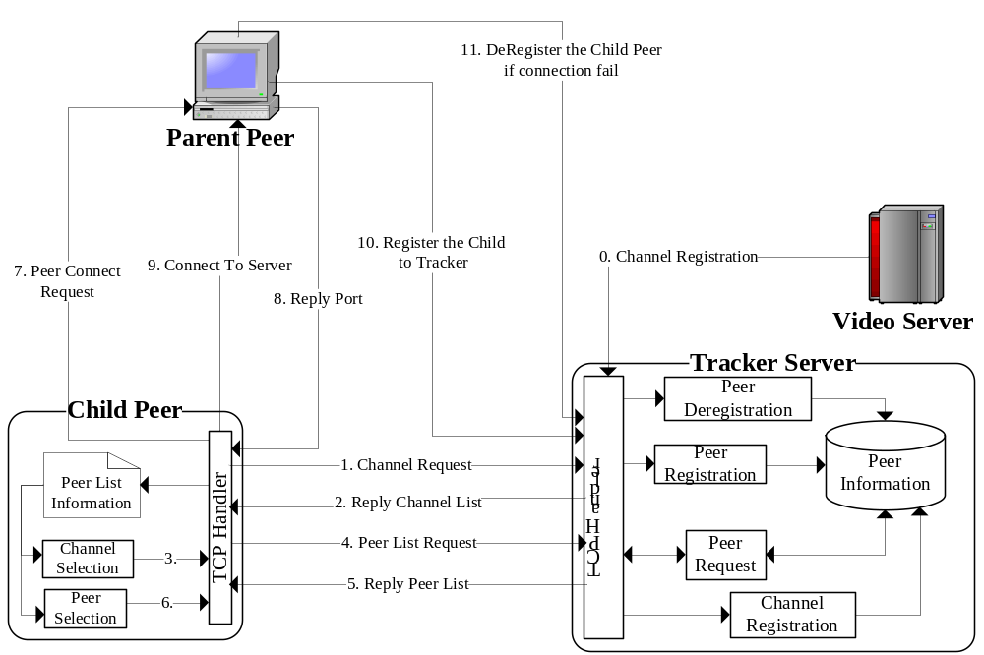Fig. 4.1 Tracker Operation model in P2P IPTV system
In our P2P TV system, tracker server has the identical function with other trackers in different P2P systems. It maintains the channels, servers and peers information and provides 4 main functions:
- Channel registration
- Peer list request
- Peer registration
- Peer deregistration
These functions will support all the peers in the system to establish and maintain their connection with different peer and video streaming.
- Channels Selection and Connection (Cheng Wen Chi)

  - Connection establishment and registration

The operation of the entire P2PTV system is started with the registration of a streaming server. When the streaming server registered tracker server, a new broadcast channel is established. The registration message defines the channel details include channel name, server IP address and channel number. Tracker server will then create a new peer list for each tree and maintain the information in the channel.

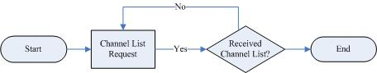
Fig. 4.2 Flow Chart of channel information request

In Figure 4.2, it shows the flow of channel list request. When a new client joins the P2P TV system, it needs to select a broadcast TV channel from the channel list. The channel list is retrieved by client program automatically when it starts up.

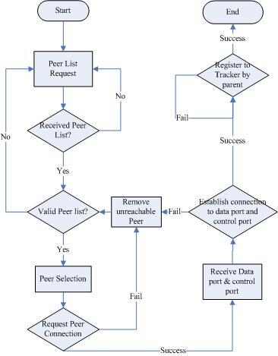
Fig. 4.3 Flow Chart of Peer registration

When user select a channel from a newly join client terminal, the client terminal will send peer list request to tracker for different trees concurrently. As the tracker is responded for the identification of peer, it will distribute a unique ID to the requested peer. After sending the unique ID to the peer, it sends out the request peer list of each tree in the channel. The new peer will validate the peer list and select a peer from list for each new connection.

In this P2P system design model, registration and deregistration processes are operated by parent peers. Parent peers are P2P peers which stream the sub stream data to its child. When a parent peer is selected by a child, the child will send a request for the data streaming port and control port. Child peers will then establish a new connection on the TCP ports which are received from its parent peer. If the TCP connection did not establish successfully, the child peer will remove the selected parent from its peer list. When all peers in the list is removed, the client program will request a new peer list from the tracker for further selection process.
These processes will be replied until the entire P2P TV sub trees are connected.

After the connections are established, parent peers will receive the peer id and IP address of the new client. By using the received information, parent will able to register its child peers to the tracker by registration request. When a peer is register in the tracker, tracker stores the child node information which is linked to its parent node. This information is used in other process, such as peer list request and deregistration of peer.

  - Deregistration and Recursive Deregistration
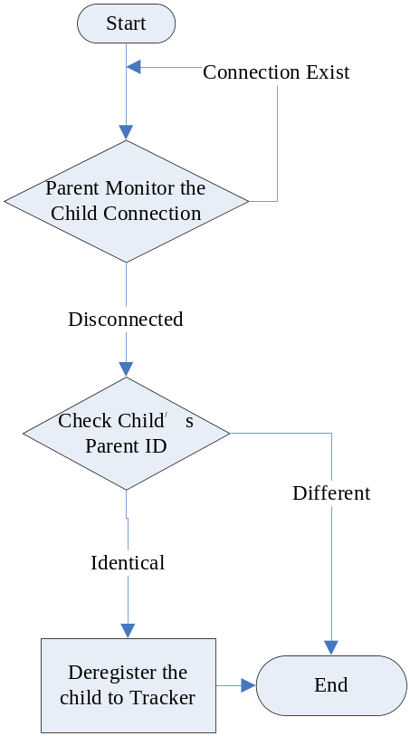
Fig. 9.4 Flow chart of deregistration

Parent peer will monitor the TCP connection between its child peers. When a peer is disconnection with its parent, parent will send a deregister message to tracker based on child id and tree id which stored locally in child connection process. Tracker receives this deregister message and it will match the id of both parent and child before remove the peer from the peer list in the tree. This avoid the incorrect deregistration of child peer.

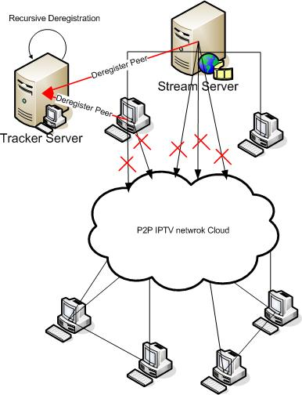
Fig 9.5 Deregistration model of P2P IPTV

In Fig 9.5 shows the case of recursive deregistration. When there is some special network event happened on the internet. (i.e. the disconnection of large subnet, down of ISP server), parent peer will not able to deregister its child peers before it is offline. As the registration and deregistration processes are relied on parent peer, this cases rises up a serious data hazard on the peer information in tracker.
To eliminate the hazard, tracker is equipped with a recursive deregistration process. When tracker deregisters a peer from a sub tree, it searches all the child peer of the deregistered node. As the parent node is disconnected, those child peers must re-registered by a new parent after they received a rebuild their sub stream. As a result, child peers who are not re-register are disconnected from the IPTV system. By comparing the searched child peer list in deregister process, the tracker can recursively remove peers which are disconnected in IPTV network cloud. This recursive process has greatly increased the accuracy of the peer list data in the tracker.

  - Peer selection in peer list
Peer selection process provides a most suitable peer for new connection in both push mode and pull mode. A health parent peers will help the client program to maintain a stable and high speed sub stream. Thus, the peer selection process is a most significant part to maintain high quantity connection.
In the design of selection algorithm, we are focused on:
- Select the best peer for new connection
- Reduce the request of peer list download
- Decentralize of selection process
- Concurrent selection of peer

The peer selection process is mainly operated on the client program. The client program records the miss chunk and disconnection log for each peer in push mode and pull mode. These records are used to calculate a grading for each peer at the local peer list. When push mode or pull mode request a peer selection, peer list will be sorted by the grading. The peers with higher grading will be selected from the peer list for further connection establishment.

- Reconnection and Loop Detection (Cheng Wen Chi)

TCP connection states are changed in different network environment. A P2P client connection will be changed dynamical based on availability of peer, peer network bandwidth, data collection. In this project, peer has individual connection in each tree for both upload and download stream. These streams are maintained by different thread, and they will connect and reconnect individually based on network condition. The following conditions are the precondition of disconnection:
- TCP timeout
- large number of miss packets
- network disconnection (offline)

When a sub stream is disconnected, it will start the reconnection process on the particular sub stream. The disconnected peer will become the root of the disconnected sub tree and response for the reconnection process and rebuild of data stream. In figure 10.1, it shows an example of disconnection diagram. Peer 5 has become the root if the left sub tree after disconnected with its parent. The video streaming of the hold sub tree has been stopped. As to avoid the TCP connection timeout during reconnection, the root peer generates WAIT message and flood it periodical to its child peers through the data streaming channel. The WAIT message includes the peer id of the root peer. This peer Id will be used as the key information in loop detection.

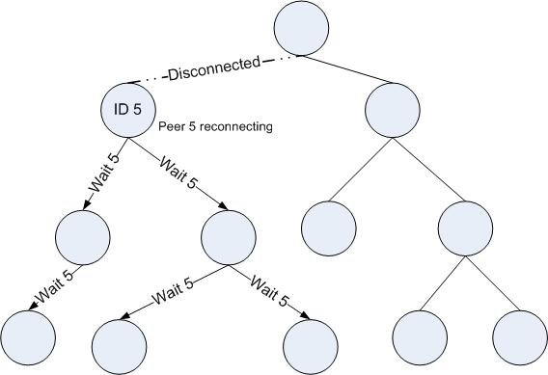
Fig. 10.1 Example of reconnection diagram

In reconnection process, sub stream will be reconnected by the connection stage processes which include peer list request, peer selection and port request.

After the sub stream is reconnected, new sub stream is validated by two additional processes:
- Chunk sequence verification
- Loop detection
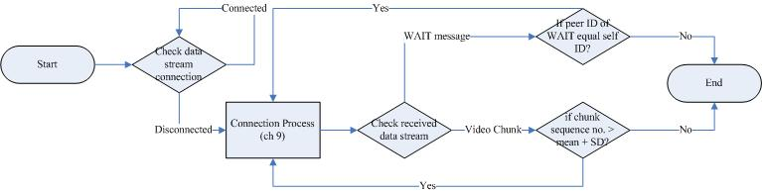
Fig 10.2 Reconnection flow chart

In loop detection process, the root peer of the reconnected tree will verify the received data from its new parent. If the received data is video chunk, it will copy the chunk to upload buffer. Otherwise, if the received data is a WAIT message, it will compare the peer id in the WAIT message with its own id. If the IDs are identical, it means there is a loop occurs in the new connection. The root peer will then release the new connection and step back to the reconnection status.

In chunk sequence verification, the first received chunk number will be compared with the mean of all sub stream receiving chunk number. If the difference of chunk sequence number is over a certain limit, i.e. 1 S.D., then the new connection will be released and re-established. The reason of applying this process is due to the transmission latency of P2P system. In internet P2P system, there is transmission latency between the connections of each peer. When the number of P2PTV users is increased, the P2P tree layer is increased. The difference of chunk sequence number of different layer peers will be widened, as the number of links is increased. If the difference is too large, the received will not able to rebuild the playback stream from the sub stream. The chunk sequence verification is a solution for this problem. It helps to eliminate the chunk sequence number difference between each sub stream.

- Pull-Mode Implementation (Choi Kwok Yam)

Pull-Mode is a missing chunk recovery mechanism. Peer departure and network congestion cause chunk losses easily. The missing chunk recovery scheme enables the peer to recover the missing chunk in the playback buffer and the upload buffer. This scheme avoids viewing quality degradation in a unstable network. The Pull-Mode is divided into two parts: detection and recovery

  - Detection

The detection algorithm implement in the state of pushing video chunk. If the peer is reconnecting to other peers, the missing chunks will not be detected in this period. The detection algorithm will be started after the peer received the second streaming chunk in each sub-stream. Figure 11.0 shows the detection algorithm of the missing chunk. The current sequence number is the sequence number of streaming chunk. The expected sequence number = last received sequence number + current sub-stream number. If the current sequence number is not equal to expected sequence number, the algorithm will calculate the total number of missing sequence between the last received sequence number and the current received sequence number. All the missing sequence number will be added to an array call missing chunks lists. The recovery algorithm will access the list to obtain the sequence number to start the recovering process.

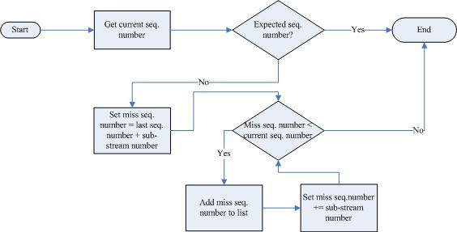

Fig.11.0 Detection algorithm
  - Recovery
Push Window
Recovery Window
Playback Window
Pushed chunk

Missing chunk
Time
Recovered chunk

Fig 11.1 model of playback buffer

Each peer maintains a playback buffer to store the chunks which received from other peers. The playback buffer contains three windows:

- Playback window
- Recovery window
- Push window

The media player displays the content from the playback window. The chunks in the push window are pushed among the other peers. Missing chunks in the recovery window are recovered using the algorithm described in figure 11.2.

When the pull button is clicked on the application GUI, the recovering process will be started. The select peer process in Charter 9.3 to retrieve a recovery peer from the peer list and then it will access an array, missing chunk list, to obtain the missing sequence number until the pull mode is off. By selected recovery peer, the recovery workload will be evenly disturbed among all peers. If the missing sequence number is smaller than the current playing sequence number in the playback buffer, the recovery message will not be sent.

The recovery peer receives the chunk recovery request from other peers. The recovery peer searched the sequence map for the missing chunk. The search result will be sent back to the peers. In the P2P live streaming system, all the missing chunks are urgently needed otherwise the quality of video will be impaired. If the peers received five consecutive empty result sets, the algorithm will select a new recovery peer again to improve the recovery rate. After the peers received a recovery chunk, the algorithm will check the playing sequence number in the playback buffer and the sequence number of recovery chunk. Set the recovery chunk to playback buffer if the playing sequence number is smaller than the sequence number of recovery chunk. The recovery chunk will be set to upload buffer directly, whatever the chunk recovering of playback buffer is success or failure.

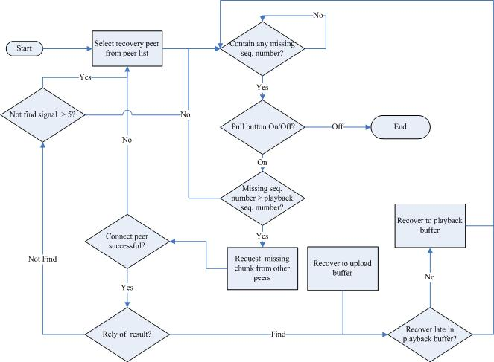
Fig. 11.2 recovering algorithm
- Statistic Application (Chiu Kwok Shing)
Peer- To- Peer Statistic tools Development.

To investigate the performance of our system, it required an application to measure the network speed of the upload and download traffic of the client application.
Thus, a connection monitor is used to keep track the performance of the client application.

This is an application that designed to monitor the upload and download speed of the client application; result obtained can be utilized to investigate the performance of the P2PIPTV application’s performance.
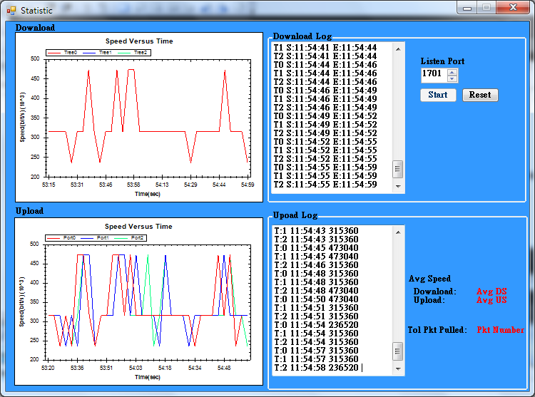
Fig.12.1 GUI of Statistic Application

As shown on the above figure, the application contains 2 major components:
- Download and Upload speed graph panel
- Download and Upload speed data log

In the graph panel, it shows the download and upload speed statistic. It will continuously update the latest download and upload speed of the client-side application and plot a line chart on the graph panel. For the download graph, line chart will show the download speed per sub-stream tree. While the upload graph will shows the upload speed per upload data port.

At the same time, speed data log of these latest download and upload speed will be updated in the field of “Download Log” and “Upload Log”. User can view the recorded time and recorded speed in the log. So user can investigate the client side application performance with the data collected.

Amount of average download and upload speed and total packet pulled are show at the right button corner of the application. User can view the overall performance of client-side application’s upload and download speed. The total number of packet obtained through pulling algorithm let us know the efficiency of pull mode in the whole system.

The graph is created using an open source library called “Zedgraph”^{[17]}, which contains a set of classes to create 2D graph. It’s a library with high flexibility for user to self-modify the contents of graph, which give us a great convenient in creating the application.

To enhance the clearness of expression, the line chart will be updated automatically from left to right continuously.

The following diagram is the control flow of the statistic tool application:
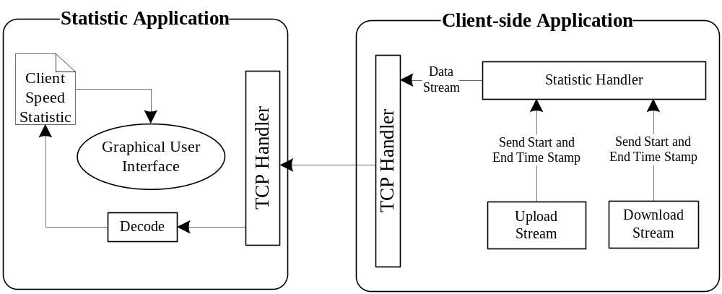
Fig.12.2 P2PTV statistic application model

While the client-side application starts the listen port that communicates with statistic application, it will keep track on the download and upload process of the client-side application.

Since the client-side application will send encoded media content one by one with fixed chunk size, we can calculate the upload and download speed easily if we recorded the time needed to send a data chunk.

The Client-side application will send the recorded data to statistic application through TCP Handler. The Statistic application will decode the received data and stored it to a data base in form of XML file. Finally the application will read data from the XML file and plot the result graph in the Graphical User Interface.
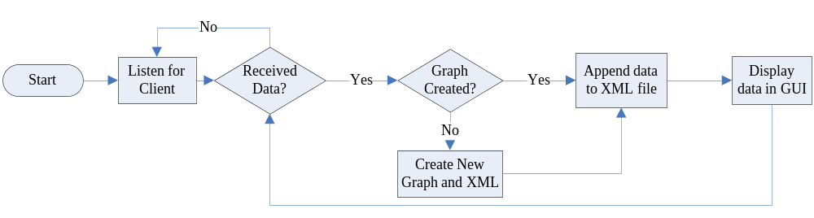
Fig.12.3 Flow chart of statistic application
First of all, user selects the listen port that communicates with the client-side application and start the program. The application will start graph plotting if it received data.

The program will keep running unless user clicks the reset button to clear all graphs, data log and XML database.

- Discussion and Conclusion

Reference
[1] Laurie Gonzalez, Marketing Director of the Broadband Forum Asia, “IPTV DEPLOYMENTS DOUBLE FOR THE SECOND YEAR RUNNING AS BROADBAND CONTINUES TO ACHIEVE STRONG GROWTH”, 15 July 2008
http://www.broadband-forum.org/news/download/pressreleeases/2008/IPTV_Deployments_Double07_15_08.pdf
[2] Internet Protocol Television (iPTV) - Global Strategic Business Report, Global Industry Analysts, Inc., March 2008, Pages: 458 http://www.researchandmarkets.com/reportinfo.asp?report_id=347969&t=t&cat_id=
[3] Xiao jun Hei, Yong Liuz and Keith W. Ross:” IPTV over P2PStreaming Networks: the Mesh-pull Approach”, Communications Magazine, IEEE, Vol. 46, No. 2. (2008)
[4] ZhenjiangLi, YaoYu, XiaojunHei, and Danny Hin-Kwok Tsang: “A Uniﬁed Framework for Sub-stream Scheduling in P2PHybrid Streaming Systems and How to Do Better?”, P. 728-741, 7th May 2009
[5] F. Pianese, D. Perino, J. Keller, and E. W. Biersack, “PULSE: An adaptive, incentive-based, unstructured P2P live streaming system,” IEEE Trans. On Multimedia, vol. 9, no. 8, pp. 1645-1660, Dec. 2007
[6] Li, Z., Yu, Y., Hei, X., Tsang, D.H.K.: “Towards low-redundancy push-pull P2P live streaming”. In: Proc. ICST QShine, Hong Kong (July 2008)
[7] Xiao jun Hei, Chao Liang, Jian Liang, Yong Liu, Keith Ross: “A Measurement Study of a Large-Scale P2P IPTV System”. In Polytechnic University, NY, USA.
[8] Susu Xie, Bo Li, Gabriel Y. Keung, and Xinyan Zhang: “Coolstreaming: Design, Theory, and Practice “, IEEE TRANSACTIONS ON MULTIMEDIA, VOL. 9, NO. 8, DECEMBER 2007
[9] Alexandro SENTINELLI, Luca CELETTO, Damien LEFOL,Claudio PALAZZI, Giovanni PAU, Theodore ZAHARIADIS, Ahola JARI: “Survey on P2P Overlay Streaming Clients”, towards the Future Internet G. Tselentis et al. (Eds.) IOS Press, 2009
[10] Broadband Consumer Education Programme, Office of the Telecommunications Authority (OFTA) - HKSAR, 11 September 2008
http://www.ofta.gov.hk/en/ad-comm/ucac/paper/uc2008p6.pdf
[11] Source: Gartner, Science & Technology Policy Research and Information Center , July 2008
http://cdnet.stpi.org.tw/techroom/market/eetelecomm/2008/eetelecomm_08_033.htm
[12] Hong Kong: The Facts, Published by the Information Service Department – HKSAR OFTA, April 2009
http://www.gov.hk/en/about/abouthk/factsheets/docs/telecommunications.pdf
[13] Estimated Coverage of Digital Terrestrial Television ( Jan 2010)
- Commerce and Economic Development Bureau - HKSAR
http://www.digitaltv.gov.hk/general/pdf/coverage.pdfx

[14] Astra Satellite Monitor survey - SES-Astra Presentation March 17, 2010
http://www.ses-astra.com/business/en/news-events/news-latest/index.php?pressRelease=/pressReleases/pressReleaseList/10-03-18/index.php
[14] http://wiki.videolan.org/Codecs
[15] http://en.wikipedia.org/wiki/Hypertext_Transfer_Protocol
[16] Alex MacAulay, Boris Felts, Yuval Fisher: “WHITEPAPER – IP Streaming of MPEG-4: Native RTP VS MPEG-2 Transport Stream”, October 2005

[17] http://zedgraph.org/wiki/index.php?title=Main_Page
[18] http://wiki.videolan.org/VLC
[19] http://en.wikipedia.org/wiki/XML
[20] http://sourceforge.net/projects/mediainfo/

Appendices
Minutes of the 1st FYP Meeting
Date : 1/6/2009
Time : 10:30AM
Place : Room 2421
Attending : Prof. Danny Tsang,
Cheng Wen Chi, Chiu Kwok Shing, Choi Kwok Yam
Absent : None
Recorder : Chiu Kwok Shing

1. Items discussed
1.1. Recommended Schedule of the project
1.2. Recommended Protocol
1.3. Possible barriers
1.4. Reference P2P protocol

2. Problems/questions
2.1. What’s the first target of our project?
Conclusion: Develop an one-to-one client-server mode video streaming model.

2.2. Packet division / sending protocol and video encoding / decoding protocol
Conclusion: Investigate the possibility of applying VLC plug-in library.

2.3 How to apply VLC library?
Conclusion: Using C# as the developing language instead of C++, further investigate the implementation method by our own.

2.4 Does there any recommended papers for P2P IPTV?
Conclusion: Cool-streaming is recommended for reference.

3. Action items/tasks
Start working on Milestone 1 – Develop a one-to-one client-server mode video streaming model.

4. Date and time of next meeting
Next meeting will be held at the June-mid, further details of meeting date and time will be confirmed later by email.

5. Meeting adjournment
The meeting was adjourned at 11:30AM.

Minutes of the 2nd FYP Meeting
Date : 23/7/2009
Time : 3:30PM
Place : Room 2421
Attending : Prof. Danny Tsang,
Cheng Wen Chi, Chiu Kwok Shing, Choi Kwok Yam
Absent : None
Recorder : Chiu Kwok Shing

1. Items discussed

1.1. Report the current progress
Finish the target tasks that set in the 1st FY P meeting, 1-to-1 client-server mode video streaming model was set up.

1.2. Recommendation from Prof. Danny Tsang
Redevelop the system with VLC plug-in library instead of Windows Media Player plug-in.

1.3. Possibility of Implement MDC on our system

2. Action items/tasks
Implement the 1-to-many client-server mode video streaming model.

3. Date and time of next meeting
Next meeting will be held at the end of summer holiday, further details of meeting date and time will be confirmed later by email.

4. Meeting adjournment
The meeting was adjourned at 4:30PM.

Minutes of the 3rd FYP Meeting
Date : 8/9/2009
Time : 4:30PM
Place : Room 2421
Attending : Prof. Danny Tsang,
Cheng Wen Chi, Chiu Kwok Shing, Choi Kwok Yam
Absent : None
Recorder : Chiu Kwok Shing

1. Items discussed
1.1. Report the current progress
Finish the task set in 2nd FY P meeting, the system can stream out the video from server to multiple users.
1.2. Recommendation from Prof. Danny Tsang
1.3. How to make the streaming data into sub-streamming.

2. Action items/tasks
Implement sub-streaming to the 1-to-many client-server mode video streaming model.
Divide the server into Main server and Video Server.

3. Date and time of next meeting
Next meeting will be held at next month, further details of meeting date and time will be confirmed later by email.

4. Meeting adjournment
The meeting was adjourned at 5:30PM.

Minutes of the 4th FYP Meeting
Date : 15/10/2009
Time : 4:30PM
Place : Room 2421
Attending : Prof. Danny Tsang,
Cheng Wen Chi, Chiu Kwok Shing, Choi Kwok Yam
Absent : None
Recorder : Chiu Kwok Shing

1. Items discussed
1.1. Report the current progress
Finish the tasks that set in the 3rd FYP meeting.
1.2. Recommendation from Prof. Danny Tsang
1.3. Possibility that apply MDC on our system
Implementation on MDC will be further discussed by Prof. Danny Tsang and TA, recommendation and guidance would be given if they made a conclusion.

2. Action items/tasks
Develop a feasible P2P algorithm to our system; convert the system from client-server model to P2P model.

3. Date and time of next meeting
Next meeting will be held at next month, further details of meeting date and time will be confirmed later by email.

4. Meeting adjournment
The meeting was adjourned at 5:15PM.

Minutes of the 5th FYP Meeting
Date : 22/12/2009
Time : 4:30PM
Place : Room 2421
Attending : Prof. Danny Tsang,
Cheng Wen Chi, Chiu Kwok Shing, Choi Kwok Yam
Absent : None
Recorder : Chiu Kwok Shing

1. Items discussed
1.1. Report the current progress
Finish the tasks that set in the 4th FYP meeting.
1.2. Recommendation from Prof. Danny Tsang
1.3. Add a tool to monitor the peers, draw graph to make statistics.
1.4 Disconnection selection improvement, parent selection while reconnection.
1.5 MDC will not be applied into the project due to technical issue and short out of time.

2. Action items/tasks
Applied Pull-mode P2P streaming into the system to make it run as Hybrid Mode.
Add a statistic tool to record the network behavior.
Enhance the Graphical User Interface.
Prepare a demo on our system in the next meeting.

3. Date and time of next meeting
Next meeting will be held at beginning of February, further details of meeting date and time will be confirmed later by email.

4. Meeting adjournment
The meeting was adjourned at 5:15PM.

Minutes of the 6th FYP Meeting
Date : 10/2/2009
Time : 4:30PM
Place : Room 3117
Attending : Prof. Danny Tsang,
Cheng Wen Chi, Chiu Kwok Shing, Choi Kwok Yam
Absent : None
Recorder : Chiu Kwok Shing

1. Items discussed
1.1. Report the current progress
Finish the tasks that set in the 5th FYP meeting.
1.2. Demonstration in the laboratory
1.3. Recommendation from Prof. Danny Tsang

2. Action items/tasks
Avoid looping while reconnection and multi-channel will be applied into the project.

3. Date and time of next meeting
Next meeting will be held at next month, further details of meeting date and time will be confirmed later by email.

4. Meeting adjournment
The meeting was adjourned at 5:15PM.

